

CS565 .Net Programming-Fall 2015

Professor Wiselin Mathuram

**Final Report 1**

by

Yarram, Sudha (143077)

Submission Date: December 5, 2015 3.00pm PST

Student Registration Form:

Screen Shot:

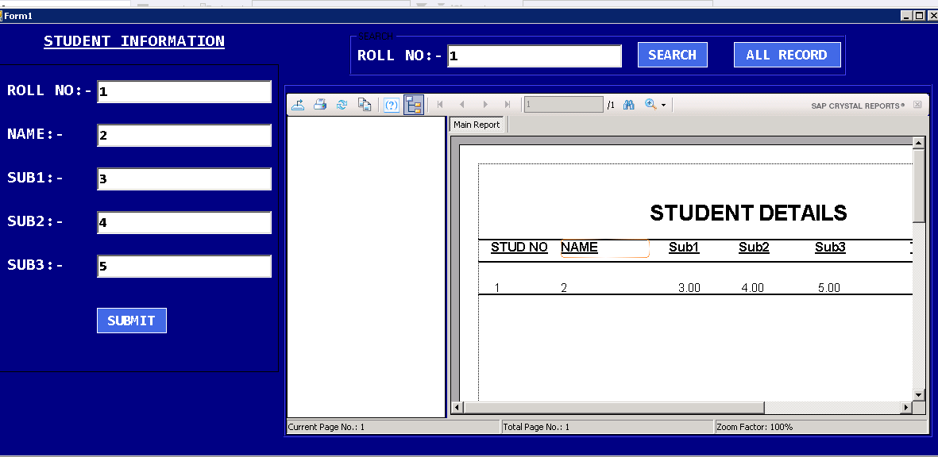

Execute:

Columns are not nullable

To run : Ctrl-F5 or F5.

App.config:

<?xml version="1.0"?>

<configuration>

<configSections>

</configSections>

<connectionStrings>

<add name="PRG25_STUD_CRYSTAL_DEMO.Properties.Settings.dbStudentConnectionString"

connectionString="Data Source=(LocalDB)\v11.0;AttachDbFilename=|DataDirectory|\dbStudent.mdf;Integrated Security=True;User Instance=False"

providerName="System.Data.SqlClient" />

</connectionStrings>

<startup useLegacyV2RuntimeActivationPolicy="true"><supportedRuntime version="v4.0" sku=".NETFramework,Version=v4.0"/></startup></configuration>

**Note: Change the Source to your local Database Name.**